**Report for internship task 2:**

**Name: Saad bin haroon**

**Internship iD: TN/IN02/PY/026:**

**GitHub link:** [**https://github.com/Saad-Bin-Haroon/internship-task-2.git**](https://github.com/Saad-Bin-Haroon/internship-task-2.git)

**Task Objective:**

The objective of this task is for how to used different topic like tuples,functions ,etc in the code:

**Code Snippets:**

1. students = ["Saad", "khabib", "topouria", "olivera", "khamzat"]

for student in students:

    print(student)

1. students = ["Saad", "tony", "khabib", "john jones", "machackev"]

reversed_students = students[::-1]

print("Reversed list:", reversed_students)

Student record CRUD in dict.

4: students = {}

*def* create(*name*, *marks*):

    students[name] = marks

*def* read(*name*):

    return students.get(name, "Not found")

*def* update(*name*, *marks*):

    if name in students:

        students[name] = marks

*def* delete(*name*):

    students.pop(name, None)

create("saad", 80)

print(read("saad"))

update("saad", 90)

delete("saad")

print(read("saad"))  *# Should print 'Not found'*

**screenshots:**

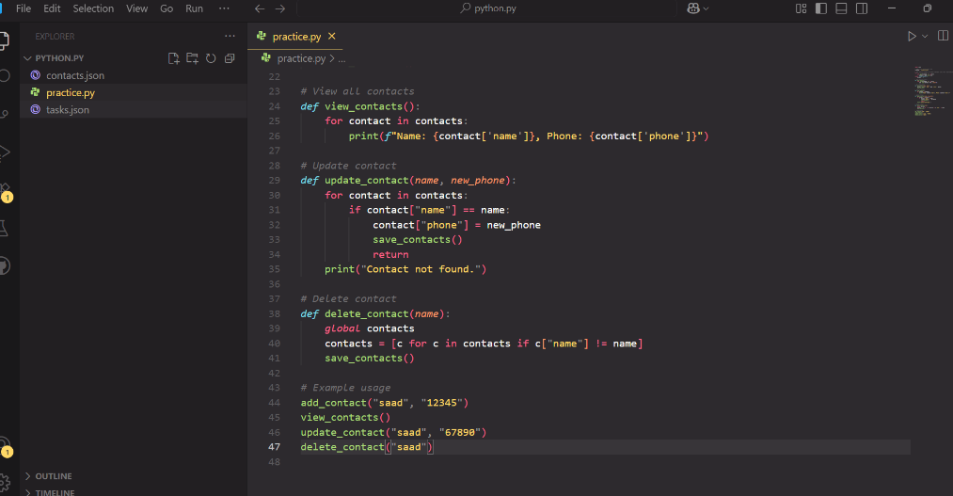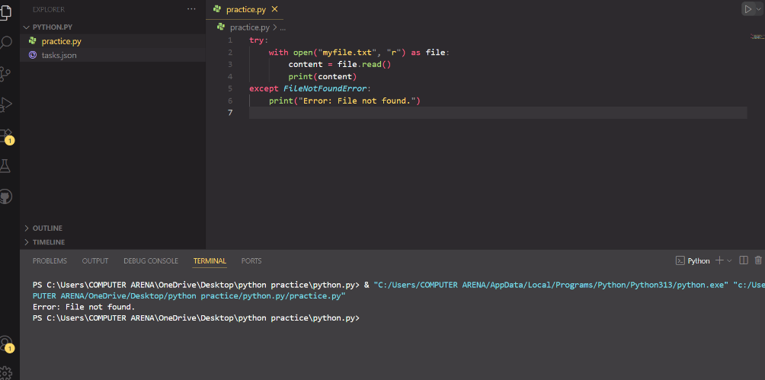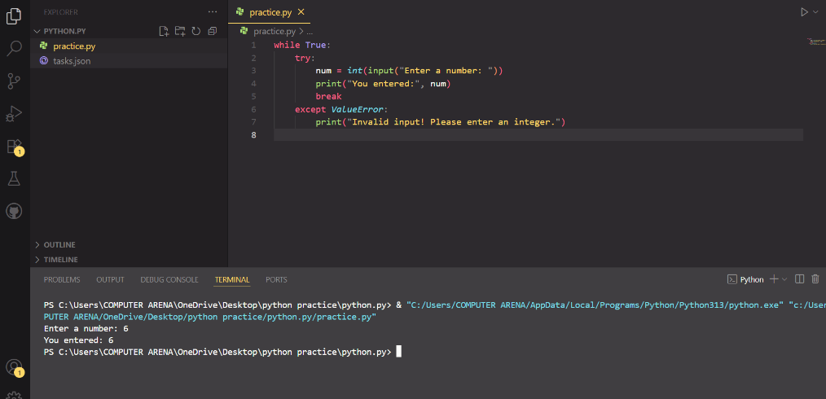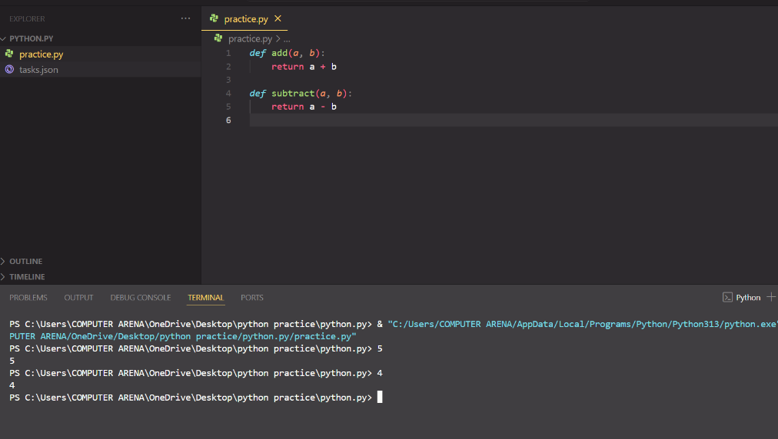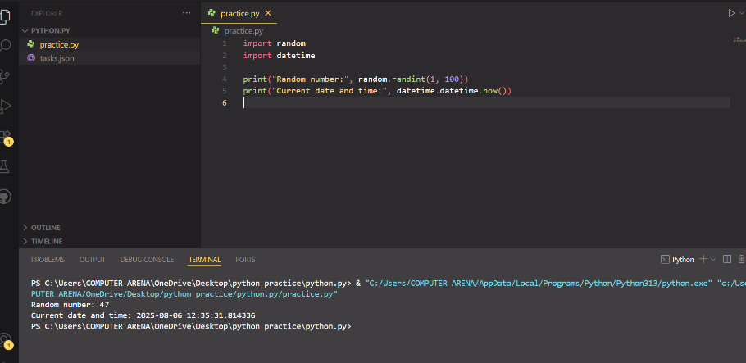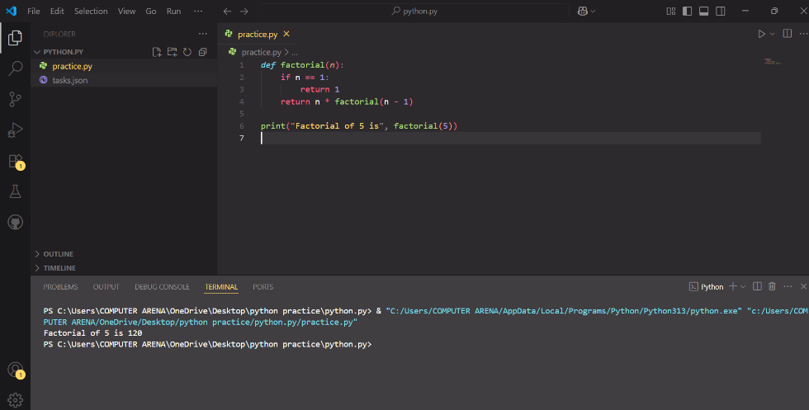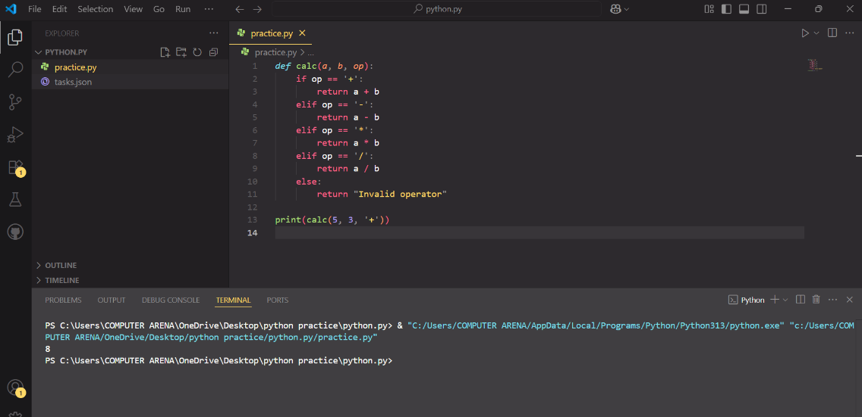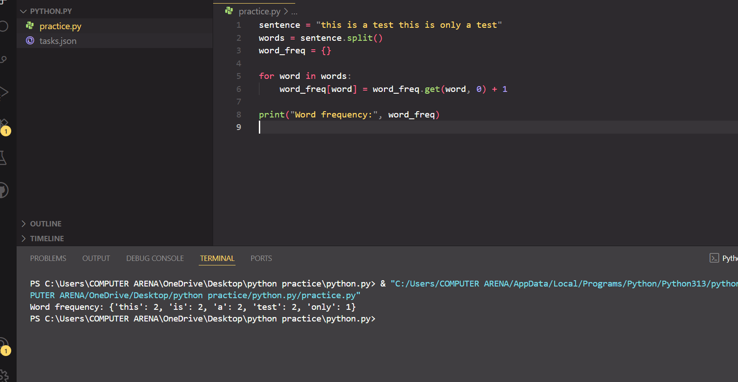

**Reflections:**

In this task I learn about **moduls** and **dictionries** in Python. First time I no understand modul, but later I import one file to another file and then I know how modul work. I try to make my own modul with some function inside, and then I use it in other file. It working good.

Dictionry is like list but with key and value. I use dictionry to store data like name and age. At first I do mistake like I try to access with number, but then I remember need to use key. I also learn how to add new item in dictionry and how to delete.

Sometime I get confuse with syntax and spelling mistake, but I fix it after try many time. This task help me understand more better how to use modul and dictionry. I feel more good with Python now.

**✅ End of Report:**